MayaSim Model: Components

The MayaSim model comprises of several components each representing states and processes of the Ecosystem and Society of the ancient Maya. The model has 4 spatial dataset as initial input. These are Elevation, Precipitation, Mean annual Temperature and Soilproductivity. All other variables are derived from those. To match scaling with the MayaSim Model in Netlogo, the Slope variable is imported as as a 5th initial dataset.

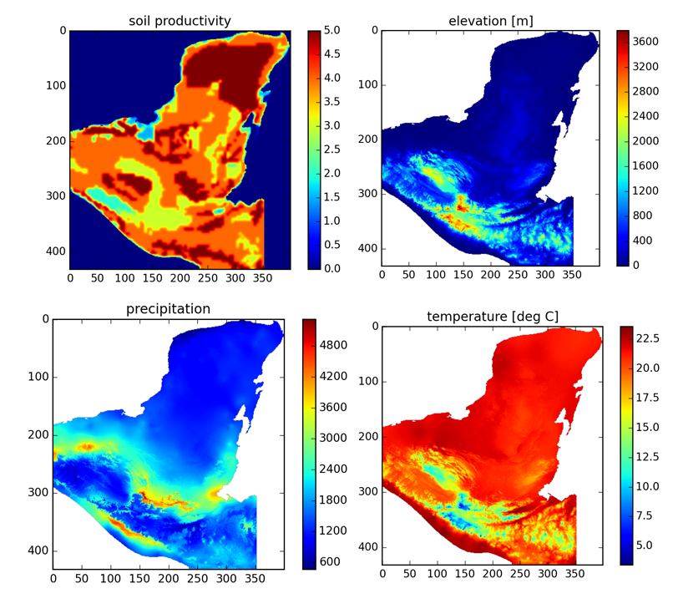
Fig. 1: Initial datasets

Ecosystem components:

The Ecosystem comprises Rain, Net Primary Productivity (npp), waterflow (wf), forest state and soil degradation as spatial variables. The role of the Ecosystems as resources for the Maya society is translated via two variables, Agricultural Productivity (ag) and Ecosystem Services (es). The feedback of the settlements on the Ecosystems is two-fold as well. Forest degradation is enhanced if there is a settlement around, and soil is degraded for cells that are cropped.

rain_function(t,cleared_land_neighbours)
parameters:
veg_rainfall = 0
output:
rain = modulation * precip – veg_rainfall * cleared_land_neighbours

Modulates the initial precipitation dataset with a 24 timestep period. If veg_rainfall≠0, neighbouring cells without forest (cleared_land_neighbours) decrease rain.

net_primary_prod(t,rain)
output:
npp = 3000 * np.minimum(1 - np.exp((-6.64e-4 * rain)),
1./(1+np.exp(1.315-(0.119 * temp))))
Net primary productivity

Waterflow
get_waterflow(rain_volume)
parameters:
precip_percent = 0.25
rain_steps = 10
output:
waterflow

The waterflow distribution is generated by an agent-based model. Initially, 'drops' of water are distributed on a ratio of the land that is given by precip-percent. Their volume is given by the precip-dataset. Then, the raindrops are allowed to flow, i.e. for a number of iterations they move to the neighbouring cell with lowest altitude. The result is a flow pattern of rivers and lakes.

Forest
forest_evolve(npp,pop_gradient)
parameter:
natprobdec = 0.003
The forest is represented by a three-state-model. For each cell, the forest can be in state 3 (climax forest), state 2 (secondary regrowth) or 1 (cleared land). The state is degraded with a probability (Probdec). Without settlements around, there is a natural disturbance rate (represented by natprobdec = 0.003). Adjacent settlements influence the forest by the
population gradient, which increases the degradation probability. Recovery takes place if the time since last disturbance exceeds a treshold. For recovery to climax forest (state 3) it is also necessary to have a certain number of neighbouring cells with climax forest.

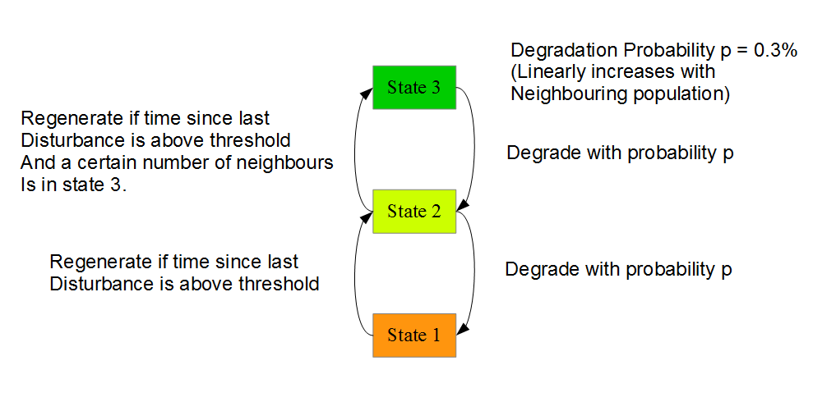
Fig. 2: Three states of the forest model

get_agri(npp,wf)
parameters:
a_npp = 0.14
a_sp = 84
a_s = 18
a_wf = 400
output:
ag = a_npp*npp + a_sp*soilprod - a_s*slope - a_wf*wf – soil_deg

Agricultural Productivity is represented by a linear combination of factors with different weights. Net Primary Productivity and Soilproductivity enter positively, Waterflow and Soil degradation are have a negative influence.

get_ecoserv(ag,wf,forest)
parameters:
e_ag = 0.06 # weight for agricultural productivity
#e_r = 1. # XXX: rain not included in current netlogo version
e_wf = 40. #waterflow
e_f = 45. #forest
output:
es = e_ag*ag + e_wf*wf + e_f*(forest-1.) #+ e_r*rain(t)

Ecosystem services is the second wrap-up variable that serves as a bridge between ecosystem and society. It comprises Agricultural Productivity, Waterflow and forest as positive factors. In MayaSim documentation, Rain is another factor, but in the current NetLogo version it is outcommented.

benefit_cost(ag)
parameters:
max_yield = 1100
origin_shift = 1.11
slope_yield = -0.0052
bca = (max_yield*(1-origin_shift*np.exp(slope_yield*ag_In)))

Benefit cost assessment describes the yield society can draw from agriculture. It is realized as a function of Agricultural Productivity exponentially saturating towards a maximum yield value.

Society components:

Settlements
Initially, a specified number of settlements is spawned on the map. The settlements perform agriculure, take advantage of ecosystem services and, if they reach a defined size,
establish a trade network.

get_cells_in_influence()
Cells in influence are those cells which lie in a radius around the settlement which scales with Population.///

get_cropped_cells(bca)
parameters:
estab_cost = 900
ag_travel_cost = 950
To acquire new cells, agricultural population density
(population/(number_cropped_cells*area)) has to exceed a threshold. If this is the case, the decision which cell to aquire depends on a utility which includes establishment cost and an agricultural travel cost that scales with distance to the settlement. The cell in influence with the maximal utility(which has to be >0)will be chosen. If agricultural population density is beneath a threshold, the cell with the lowest utility will be abandoned. Also, cropped cells whose utility<0 will be given up.

get_crop_yield(bca)
The crop yield is given as mean bca of cropped cells including all cells where bca>0. Taking the sum would probably make much more sense. This could be changed as long as one takes care that the fine-tuning of parameters is not disturbed.

get_eco_benefit(es)
Ecosystem Benefit is the mean of Ecosystem Services of cells in influence. Here again, one could think about changing the mean to a sum.

get_pop_mig()
parameters:
birth_rate = 0.15
min_death_rate = 0.005
max_death_rate = 0.25
min_mig_rate = 0.00
max_mig_rate = 0.15
output:
death_rate = -(max_death_rate – min_death_rate) * real_income_pc +max_death_rate

mig_rate = -(max_mig_rate - min_mig_rate)* real_income_pc + max_mig_rate

Population development is governed by birth rate, death rate and migration rate. Birth rate is fixed at 0.15 for each settlement. There is the option of switching birth control on, which decreases birth rate for settlements with population over 5000. Until now, this does not prevent the Maya society from a collapse.
Death rate scales inversely with total real income per capita with a maximal death rate given by 25%. Migration rate also scales inversely with total real income per capita. The number of people willing to leave the city is given by population*mig_rate.
For this to make sense, real income per capital should be normalized to lie between zero and one. Otherwise, migration and death rate are not bounded from below.

get_pop_gradient()
Population gradient is a quantity that represents the disturbance of the forest by society.
It is nonzero within the area of influence of a city, maximal in the center and decreases towards the margin. It scales with population of the settlement.

evolve_soil_deg(soil_deg,forest)
parameters:
deg_rate = 5.0
reg_rate = 2.5
Soil degrades with a defined rate if it is used for agriculture. If it is left undisturbed, it can regenerate if the forest of that cell is climax forest (state 3).

get_rank()
parameters:
tresh_1 = 4000.
tresh_2 = 7000.
tresh_3 = 9500.
For trade, the settlements are assigned ranks depending on their population. Initially, rank=0. With rank 1, the city becomes a trader. Cities with higher rank establish more connections and have a further outreach.

build_routes()
Settlements that are traders establish connections to neighbouring traders.

get_comps()
Evaluates the size of the network component for each settlement.
get_centrality()
Centrality measures the importance of a settlement in the trade network. In this case, it is represented as the longest shortest path within the component. Actually, centrality is a paradoxical way of naming, as low centrality is assigned to settlements that are central in
in the way that they can reach all the other traders in the component within a few steps.
Anyway, it is left as it is to match with the MayaSim Netlogo version.

get_trade_strength()
output:
trade_strength = 1./30.*( 1 + comp_size/centrality )**0.9
Trade strength increases with component size and decreases with centrality. The benefit of the trade network is thus created by the trade network itself, just by having connections to other cities, without taking any goods into account that are traded.

get_real_income_pc()
parameters:
r_bca = 1.1
r_es = 10.
r_trade = 6000.
output:
real_income_pc= 1/population *
( r_bca * crop_yield + r_es * eco_benefit + r_trade * trade_strength )

Real income per capita combines all three sources of income in a weighted sum, divided
by population.

migration(es)
parameters:
mig_TC_pref = -0.1
mig_ES_pref = 0.3
If the migrant population of a city is larger than 400, those people migrate. Therefore, vacant cells, that are not cells of influence of any city are taken into account. To decide where to found a new settlement, 75 cells are drawn randomly from vacant cells. For those, a utility function determines the decision. Travel cost (which means distance from mother city) and Ecosystem services enter linearly. The site with maximum utility is chosen. However, only if there is no other settlement within a radius of 7.5, a new settlement will be founded. Therefore, the function newcity(a,b,mig_pop) is called.

newcity(a,b,mig_pop)
Spawns a new city at coordinate (a,b) with population = mig_pop.

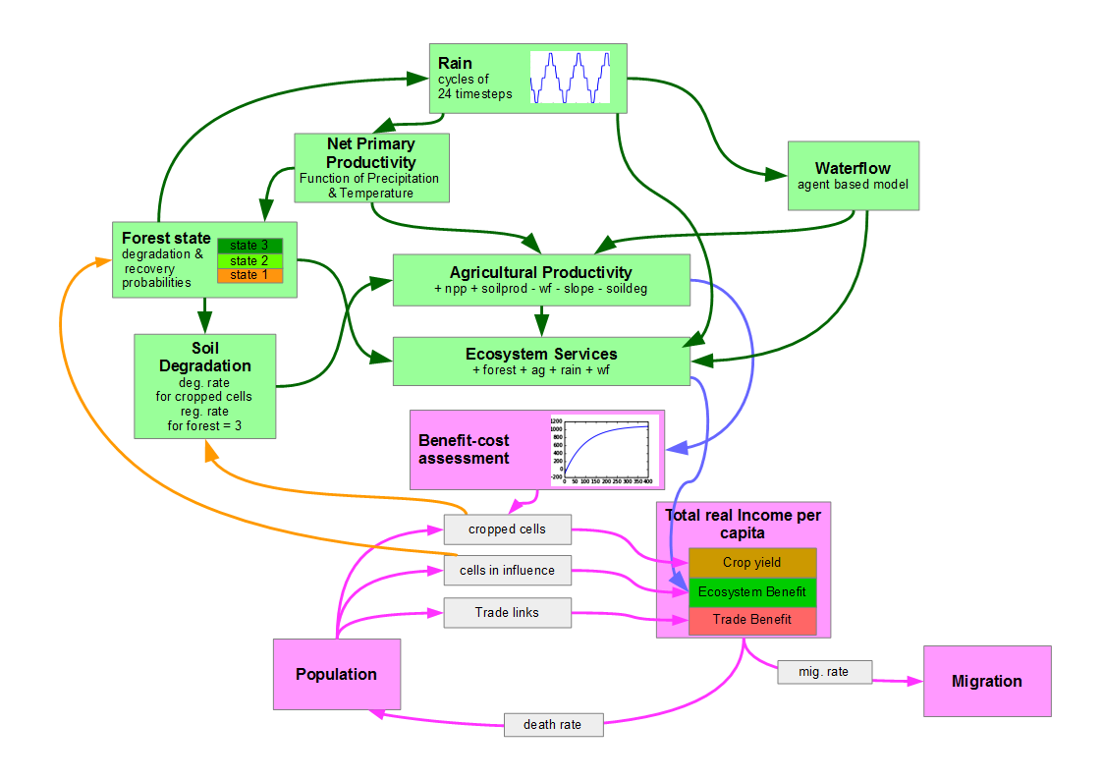
Fig. 3: MayaSim model overview

For MayaSim Netlogo Version, see:
https://www.openabm.org/model/3063/version/4/view

